DOI: 10.32604/cmc.202x.0xxxxx

**ARTICLE/REVIEW/EDITORIAL/CASE REPORT**…

**FireLite: Leveraging Transfer Learning for Efficient Fire Detection in Resource-Constrained Environments**

Md. Maruf Al Hossain Prince1, Mahamudul Hasan Masum2, Abu Saleh Musa Miah3*, Md Habibur Rahman2, Md Azam Hossain4 and Mohammad Samar Ansari5

1German University Bangladesh, Gazipur, 1702, Bangladesh

2University of Chester, Birmingham, United Kingdom

3The University of Aizu, Japan

4Islamic University of Technology (IUT), Gazipur 1704, Bangladesh

5Athlone Institute of Technology, Ireland

*Corresponding Author: Abu Saleh Musa Miah. Email: [author@institute.xxx](mailto:author@institute.xxx)

Received: XXXX Accepted: XXXX

**ABSTRACT**

Fire hazards are extremely dangerous, particularly in sectors such the transportation industry where political unrest increases the likelihood of their occurring. By employing IP cameras to facilitate the setup of fire detection systems on transport vehicles losses from fire events may be prevented proactively. However, the development of lightweight fire detection models is required due to the computational constraints of the embedded systems within these cameras. We introduce "FireLite," a low-parameter convolutional neural network (CNN) designed for quick fire detection in contexts with limited resources, in answer to this difficulty. With an accuracy of 98.77%, our model—which has just 34,978 trainable parameters—achieves remarkable performance numbers. It also shows a validation loss of 8.74 and peaks at 98.77 for precision, recall, and F1-score measures. Because of its precision and efficiency, FireLite is a promising.

**KEYWORDS**

Fire Detection; Embedded Systems; Lightweight Model; Transfer Learning; Deep Learning

|  |
| --- |
|  |

**1 Introduction**

Fire occurrences provide a constant risk to many different industries, but the transportation sector is especially vulnerable to the devastating effects of these events [1]. Politically unstable locations are known to have higher rates of fire dangers, which can result in higher risks and costs for the transportation industry. Proactive steps must be taken to quickly identify and reduce fire threats since they have the potential to cause accidents on everything from passenger trains to cargo ships [2].

Conventional fire detection techniques, which depend on human interaction or crude alarm systems, frequently fail to provide prompt responses, leading to serious damage and, in certain circumstances, the sad loss of life. However, the integration of intelligent systems into already-existing infrastructure, like IP cameras, presents a particularly promising route for improving fire detection capabilities, given the advances in computer vision and deep learning [3].

Implementing IP cameras that are fitted with fire detection models is a compelling way to improve safety protocols in the transportation industry. Through the utilization of IP cameras' widespread availability and their capacity to get real-time, high-definition footage, automated fire detection systems that can anticipate possible threats may be put into place.

Nevertheless, creating fire detection models appropriate for IP camera embedded systems deployment is a significant problem. These devices usually have limited memory and processing capacity thus it is necessary to build lightweight versions that can function well without sacrificing detection accuracy. This paper makes the following contributions:

* We present "FireLite," a low-parameter convolutional neural network (CNN) designed for fast fire detection in contexts with limited resources. For real-time fire detection applications in the transportation industry, FireLite provides a practical solution by refining the model architecture to reduce processing needs while maintaining detection accuracy.
* We have utilized the technique of transfer learning, a novel approach that had not been previously integrated into this particular field to the best of our understanding.
* We provide complete experimental findings showing FireLite's effectiveness in accurately and efficiently identifying fire occurrences with low computing overhead, as well as in-depth insights into the design and implementation of the system.

The remainder of this paper is organized as follows: Section 2 provides an overview of related work in the field of fire detection and highlights the significance of lightweight models for practical deployment. Section 3 presents the methodology employed in the design and training of FireLite, including dataset in Subsection 3.1 and model architecture in Subsection 3.2. In section 4, we present the evaluation results of FireLite compared to existing approaches. Finally, Section 5 concludes the paper with a summary of findings and outlines directions for future research in the field of fire detection and prevention.

**2 Related Work**

Lightweight fire detection models for real-time applications have advanced significantly in the last few years, especially in the context of Internet of Things (IoT) devices. The subsequent segment offers a thorough synopsis of noteworthy advancements in this field, emphasizing pivotal techniques, datasets employed, and performance indicators attained by every strategy.

FireNet is a lightweight fire and smoke detection model that was created especially for real-time Internet of Things applications by Jadon et al. [4] By utilizing the FireNet dataset, which consists of 16 videos without fire and 46 videos with fire, the model was able to reach a parameter count of 646,818. The model exhibited remarkable performance measures, including 96.53% accuracy, 97% precision, 94% recall, and 95% F1-score. On the other hand, the false negative rate was recorded at 4.13%, and the false positive rate at 1.95%. Shees et al. [5] suggested FireNet-v2, an improved lightweight fire detection model designed for real-time IoT applications, building on the framework established by FireNet. Using 363 fire and 3201 non-fire images from the FireNet and Foggia datasets [6] combined, the model reached a parameter count of 318,460. Impressively, FireNet-v2 demonstrated notable gains in performance, with an accuracy of 98.43%. However, they did not use additional matrices for evaluating performance, such as precision, recall, F-1 score, false positive, and false negative. This may cause a model to become overfit. FireNet-Tiny, a very effective fire detection model with a very tiny parameter count, was suggested by Oyebanji et al. [7] By utilizing the FireNet dataset, the model was able to reach a count of 261,922 parameters. With an accuracy of 95.75%, FireNet-Tiny showed remarkable performance in spite of its small design. Even while current techniques have advanced the creation of lightweight fire detection models significantly, each has its own advantages and disadvantages. Interestingly, both models have different counts of parameters—646,818 in FireNet and 171,234 in FireNet-Micro, for example—which emphasizes how crucial model efficiency is. Specifically, FireLite, our suggested model, stands out with 34,978 parameters count and comparable performance metrics. FireNet-Micro[8], which is equipped with a total of 171,234 parameters, demonstrates superior performance in terms of accuracy when compared to alternative models. This is evidenced by its remarkable achievement of 96.78% accuracy coupled with an impressive recall rate of 98%. Nevertheless, it is important to note that FireNet-Micro displays a lower precision level, standing at 89.90%, along with an F1-score of 93.77%.

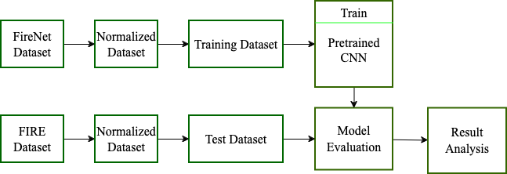By means of extensive testing and assessment, we prove that FireLite is effective in tackling the computational limitations present in embedded systems, providing a workable solution for quick fire detection in contexts with limited resources.

**Figure 1:** Proposed approach workflow

**3 Proposed Approach**

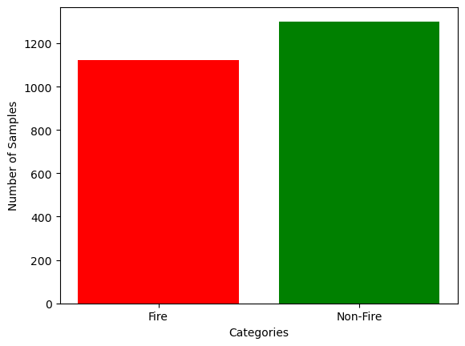Using the FireNet Dataset, first presented by Jadon et al. [4] we utilized pretrained MobileNet[9] model on ImageNet dataset [10]. The intricate workflow of our procedure is depicted in Fig. 1. More information about the dataset we have used and our CNN model is provided below.

**Figure 2:** Number of fire and non-fire images of FireNet dataset

***3.1 Dataset***

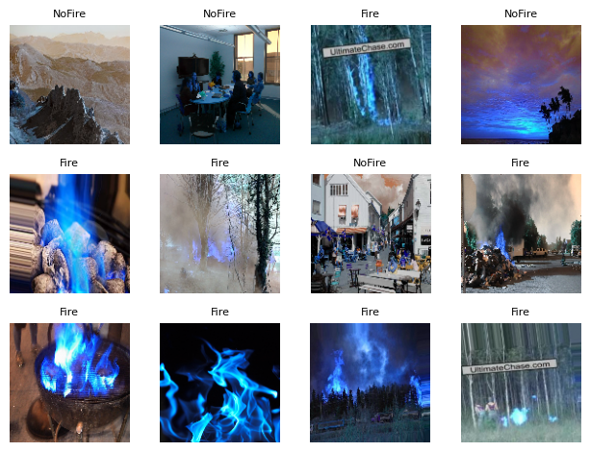We utilized two datasets namely the FireNet dataset and the FIRE dataset. The description of both datasets is provided below:

**Figure 3:** FireNet dataset sample images

***3.1.1 FireNet Dataset***

We have employed this dataset exclusively for the purposes of training and validation. The entire dataset comprises of 16 non-fire films (6,747 frames), and 46 fire videos (19,094 frames). There are 1,124 images of fire and 1,301 images of non-fire in the collection. Fig. 2 shows a bar chart of the number of samples. Despite the dataset's seeming tiny size, it is incredibly diversified. The images in the dataset are a combination of photos from the internet (Flickr and Google) plus a small sample of fire and non-fire images from the datasets of Foggia et al. [6] and Sharma et al. [11]. To preserve the dataset's diversity, Sharma's dataset was augmented and random selected a 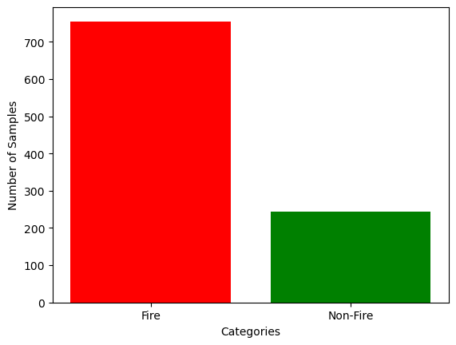few images. Fig. 3 depicts a few images from the sample dataset.

**Figure 4:** Number of fire and non-fire images of FIRE dataset

***3.1.2 FIRE Dataset***

The dataset was formed by a team of individuals during the NASA Space Apps Challenge in 2018, with the goal of using the dataset to build a model that can detect fire-related imagery. The dataset is publicly available at Kaggle [12]. This dataset comprises 755 images depicting outdoor fires, some of which exhibit significant smoke, along with 244 nature images depicting elements such as forests, trees, grass, rivers, people, misty forests, lakes, animals, roads, and waterfalls. It is evident that the dataset exhibits skewness, indicating an unequal distribution of samples between the two classes. We utilized this dataset exclusively for the purpose of conducting tests. Furthermore, it is imperative to note that said dataset was not incorporated during the training or validation stages. Fig. 4 and Fig. 5 depicts a bar 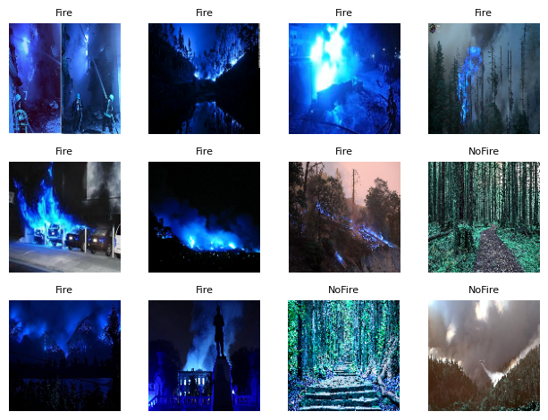chart of the number of samples and a few sample images from the dataset respectively.

**Figure 5:** FIRE dataset sample images

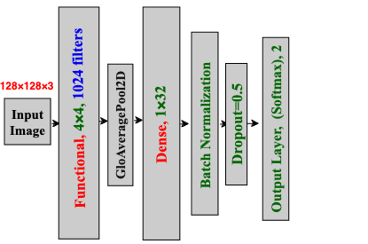

**Figure 6:** Proposed model architecture

***3.2 Model Architecture***

Fig. 6 illustrates the proposed network's whole architectural diagram. We utilized a transfer learning strategy employing the MobileNet [9] architecture which had been pre-trained on the ImageNet dataset [10]. The MobileNet model, pre-trained, was employed without its classification layers, functioning as a feature extractor to capture meaningful representations from input images. This approach facilitated the utilization of high-level features that had been learned from a variety of objects in the ImageNet dataset. To customize the model for our particular task, we trained only the top two layers of the MobileNet architecture while keeping the other layers fixed. This strategy of fine-tuning enabled us to adjust the pre-trained features to our dataset while maintaining the generalization abilities acquired from the ImageNet dataset. The initial layer was the MobileNet base model, followed by a GlobalAveragePooling2D layer to decrease the spatial dimensions of the feature maps extracted by the MobileNet backbone. Following this, a Dense layer with 32 units and ReLU activation function was added, enhanced with batch normalization for training stability and dropout regularization (dropout rate = 0.5) to address overfitting. These regularization methods were implemented to enhance the model's resilience and prevent it from memorizing noise in the training data. The output layer consisted of a Dense layer with softmax activation, enabling the prediction of a probability distribution over the target classes for multi-class classification. In our binary classification task, the output layer had two units corresponding to the two target classes. We applied the sparse categorical cross-entropy loss function, appropriate for tasks involving multi-class classification with integer labels. The Adam optimizer was employed for model training, providing adaptive learning rates and momentum optimization to accelerate convergence. Throughout the training process, we evaluated the accuracy metric to gauge the model's performance on both the training and validation sets. Training was conducted across numerous epochs, with a batch size of 32 samples per iteration to effectively utilize computational resources.

In conclusion, our model architecture utilized transfer learning with the MobileNet backbone, fine-tuning specific layers to tailor the pre-trained features to our target task. The integration of regularization techniques aimed to enhance model generalization and combat overfitting, ultimately enabling successful binary classification on our dataset.

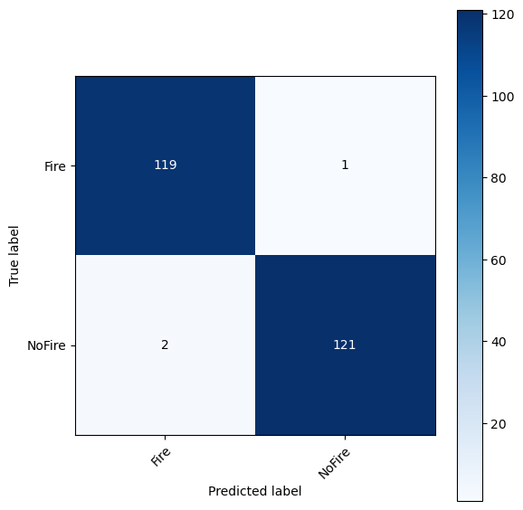

**Figure 7:** FireNet dataset confusion matrix

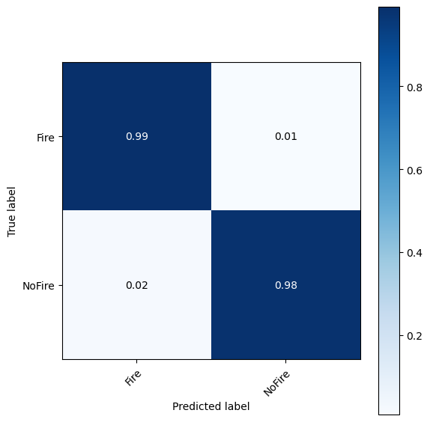

**Figure 8:** FireNet dataset normalized confusion matrix

**4 Results and Discussion**

In this examination, the efficacy of the FireNet model was analyzed on two different datasets, namely the FireNet Dataset and the FIRE Dataset. The evaluation criteria addressed a variety of crucial measures such as True Positives (TP), True Negatives (TN), False Positives (FP), False Negatives (FN), Accuracy, Precision, Recall, and F1-Score.

On the FireNet Dataset, the performance of our model was deemed commendable as it achieved an Accuracy of 98.77%. Upon examination of the confusion matrix, it was observed that there were 119 instances of True Positives and 121 instances of True Negatives, thus indicating a notable level of accurate predictions. Furthermore, the presence of merely 1 False Negative and 2 False Positives suggested a minimal occurrence of misclassification errors. The Precision, Recall, and F1-score were all computed at 98.77%, emphasizing the model's strength in precisely identifying occurrences of fire. Fig. 7 and Fig. 8 show the confusion matrix and the normalized confusion matrix, respectively.

The FireNet model performed satisfactorily with an accuracy of 86.37% when evaluated on the FIRE Dataset. The model was able to detect 680 True Positives and 182 True Negatives despite the higher magnitude of this dataset, indicating a noteworthy capacity to distinguish between fire occurrences and non-occurrences. Nonetheless, there was a need for progress in reducing misclassifications, as there were 75 False Negatives and 61 False Positives. The results of the calculation of the precision, recall, and F1-score were 86.67%, 86.37%, and 86.5%, respectively, indicating a balanced performance across many assessment measures. Fig. 9 and Fig. 10 show the confusion matrix and the normalized confusion matrix for the dataset respectively. A comparison of accuracy, precision, recall and F1-score between both the dataset is shown in the Table 1.

With a relatively modest parameter count of 34,978, FireLite demonstrates competitive performance in fire detection, with an accuracy, precision, recall, and F1-score of 98.77%. In contrast, FireNet has a substantially greater parameter count of 646,818 and achieves a little lower accuracy of 93.91%, but with a higher precision of 97% and an F1-score of 95%. Using 318,460 parameters, FireNet v2 obtains the maximum precision of 99.28% with a higher accuracy of 94.95%, but with a lower recall of 93.25% and an F1-score of 96.17%. With 171,234 parameters, FireNet-Micro outperforms other models in accuracy, attaining 96.78% and a recall of 98%. However, its precision is lower, at 89.90%, and its F1-score is only 93.77%. With a precision of 97.11%, recall of 96.62%, and accuracy of 95.75%, FireNet-Tiny. A thorough comparison is provided in Table 2.

In addition to assessing the model's performance using metrics and confusion matrices, we also depict the training and validation accuracy, as well as the training and validation loss graphs in Fig. 11, which offer insights into the model's learning progress across epochs, indicating its generalization and error minimization capabilities during training, enabling the identification of overfitting or underfitting issues and facilitating informed decisions on model design and training approaches.

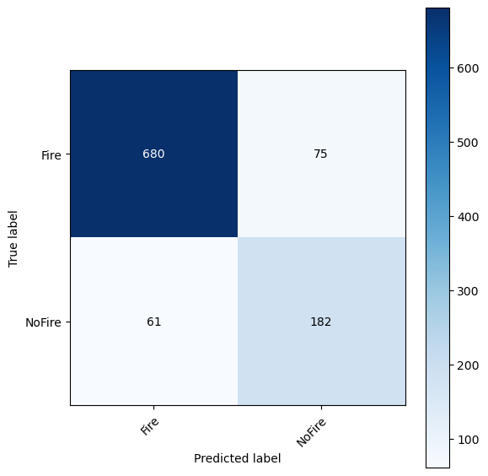

**Figure 9:** FIRE dataset confusion matrix

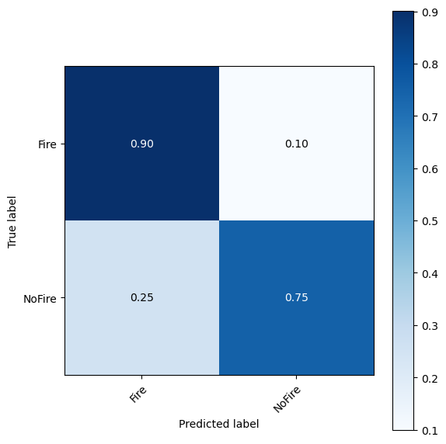

**Figure 10:** FIRE dataset normalized confusion matrix

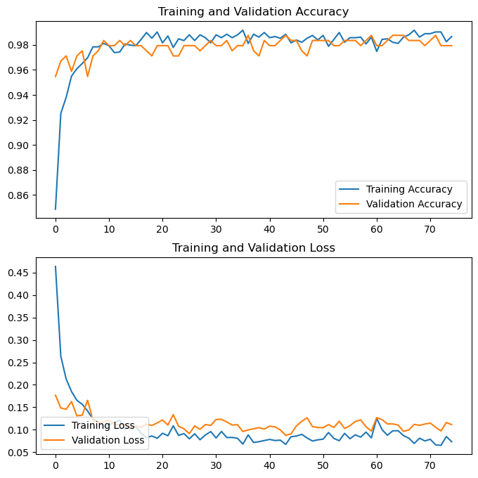

**Figure 11:** Training vs validation accuracy and loss

**Table 1:** Performance comparison between FireNet dataset and FIRE dataset

|  |  |  |
| --- | --- | --- |
| **Performance Measure** | **FireNet Dataset** | **FIRE Dataset** |
| Accuracy | 98.77 | 86.37 |
| Precision | 98.77 | 86.67 |
| Recall | 98.77 | 86.37 |
| F1-Score | 98.77 | 86.50 |
| True Positive (Normalized) | 0.99 | 0.90 |
| True Negative (Normalized) | 0.98 | 0.75 |
| False Positive (Normalized) | 0.02 | 0.25 |
| False Negative (Normalized) | 0.01 | 0.10 |

**Table 2:** Performance comparison of FireLite with other state-of-the art models

|  |  |  |
| --- | --- | --- |
| **Model** | **Accuracy (%)** | **Number of Parameters** |
| FireLite | **98.77** | 34,978 |
| FireNet [4] | 93.91 | 646,818 |
| FireNet-v2 [5] | 94.95 | 318,460 |
| FireNet-Tiny [7] | 95.75 | 261,922 |
| FireNet-Micro [8] | 96.78 | 171,234 |
| Saponara et al. [13] | 93.6 | **23,482** |
| Muhammed et al. [14] | 94.5 | 421,098 |
| Muhammed et al. [15] | 94.43 | ~7 million |

**5 Conclusion**

In this investigation, we have tackled the crucial issue of fire detection in environments with high risks, especially within the transportation sector, where the presence of fire hazards is exacerbated by political instability. Acknowledging the significance of proactive measures for fire prevention, we have introduced and formulated "FireLite," a lightweight convolutional neural network (CNN) designed for effective fire detection in settings with limited resources. Through the utilization of transfer learning utilizing the MobileNet architecture, which was pretrained on the ImageNet dataset, FireLite has displayed exceptional performance despite its minimal number of parameters. By adjusting specific layers of the MobileNet backbone and integrating regularization methods, FireLite has attained a validation accuracy of 98.77%, highlighting its accuracy and efficiency in fire detection assignments. Our assessment of FireLite has demonstrated its effectiveness in precisely identifying both fire and non-fire incidents, achieving a high overall accuracy rate. Despite a small number of misclassifications, the performance of FireLite emphasizes its potential for practical implementation in fire detection systems. A comparison with existing models has showcased the competitive performance of FireLite with significantly fewer parameters, positioning it as a promising solution for situations with computational limitations. While other models have displayed varying trade-offs in terms of accuracy, precision, recall, and F1-score, FireLite has stood out due to its balanced performance and efficiency. Further enhancements and enlargement of the training dataset could improve the reliability and effectiveness of FireLite in reducing false alarms and missed detections. Moreover, continual research endeavors can investigate methods to address the identified deficiencies and enhance the robustness of FireLite in various operational conditions.

In conclusion, FireLite marks a notable progression in lightweight fire detection models, providing a dependable and effective resolution for mitigating fire risks in environments with restricted computational capacities. The successful establishment of FireLite underscores the potential of deep learning methodologies in tackling urgent issues in fire safety, paving the way for improved prevention and response tactics in high-risk settings.

**Acknowledgement:** Acknowledgement and reference heading should be left justified, bold, with the first letter capitalized but have no numbers. Text below continues as normal. **Please be aware that the specific funding grant number should only appear in the Funding Statement.**

TSP suggests to list all non-author contributors in the acknowledgement section at the end of the paper, with details on their respective activity. Contributors include individuals in the planning, conducting, editing and/or reporting the work, and all the patients or members of the public who have kindly assisted as research volunteers. This is a good place of acknowledging their support, list their names and recognize their individual roles. TSP strongly encourages authors to fully acknowledge contributions of patients and the public towards their research, if and where appropriate.

**Funding Statement:** Authors should describe sources of funding that have supported the work, including specific grant numbers, initials of authors who received the grant, and the URLs to sponsors’ websites. If there is no funding support, please write “The author(s) received no specific funding for this study”.

**Author Contributions:** The Author Contributions statement is mandatory. It should represent all the authors and is to be included upon submission. It can be up to several sentences long and should briefly describe the tasks of individual authors. All listed authors should have substantially contributed to the manuscript and have approved the final submitted version, which should include a description of each author’s specific work and contribution.

We suggest the following format for the contribution statement:

The authors confirm contribution to the paper as follows: study conception and design: X. Author, Y. Author; data collection: Y. Author; analysis and interpretation of results: X. Author, Y. Author. Z. Author; draft manuscript preparation: Y. Author. Z. Author. All authors reviewed the results and approved the final version of the manuscript.

**Availability of Data and Materials:** This statement should make clear how readers can access the data used in the study and explain why any unavailable data cannot be released. The following five statements are offered for reference.

1. Data openly available in a public repository.

“The data that support the findings of this study are openly available in [repository name] at [URL].”

1. Data available within the article or its supplementary materials.

“The authors confirm that the data supporting the findings of this study are available within the article [and/or] its supplementary materials.”

1. Data available on request from the authors.

“The data that support the findings of this study are available from the corresponding author, [author initials], upon reasonable request.”

1. Data not available due to [ethical/legal/commercial] restrictions.

“Due to the nature of this research, participants of this study did not agree for their data to be shared publicly, so supporting data is not available.”

1. “Not applicable.” (This article does not involve data availability and this section is not applicable).

**Ethics Approval (Non-Biological or Non-Medical manuscripts do not need to write this part):** Guidelines for ethical approval statements may differ based on the journal, a standard ethical approval statement will usually include:

1. Whether or not the study included human or animal subjects. In all cases, the ethical approval status of the work should be stated in the ethical approval statement.

2. The committee which approved the study.

3. The compliance documents. What policies, declarations, acts, etc.

4. Persistent identifier: reference or approval number. Include the registration ID/reference number if applicable.

**Conflicts of Interest:** Authors must declare all conflicts of interest. If there is no conflicts of interest, it should also be declared as in ex, please write “The authors declare that they have no conflicts of interest to report regarding the present study”.

**Supplementary Materials:** Supplementary Materials should be uploaded separately on submission. The supplementary files will also be available to the referees as part of the peer-review process. Any file format is acceptable; however, we recommend that common, non-proprietary formats are used where possible.

Supplementary materials should be clean, without tracked changes, highlights, comments or line numbers.

Supplementary figures must be clear and readable, and we recommend a minimum resolution of 300 dpi, figure legends must be clear and accurate.

Supplementary materials must be mentioned in the main text. The citation format of Supplementary Figure, Table, Equation, etc., should start with a prefix S (i.e., Fig. S1, Eq. (S2), Table S1, etc.).

**References**

[1] V. Kodur and M. Z. Naser, “Fire hazard in transportation infrastructure: Review, assessment, and mitigation strategies,” *Frontiers of Structural and Civil Engineering*, vol. 15, no. 1, pp. 46–60, Apr. 2021, doi: 10.1007/S11709-020-0676-6.

[2] Y.-D. Kim, G.-J. Son, H. Kim, C. Song, and J.-H. Lee, “Smart Disaster Response in Vehicular Tunnels: Technologies for Search and Rescue Applications,” *Sustainability*, vol. 10, no. 7, p. 2509, Jul. 2018, doi: 10.3390/SU10072509.

[3] X. Li, S. He, D. He, C. Li, and J. Li, “Real-Time Flame Detection Based on Video Semantic Statistical Features,” *2023 8th International Conference on Computer and Communication Systems, ICCCS 2023*, pp. 989–997, Apr. 2023, doi: 10.1109/ICCCS57501.2023.10150933.

[4] A. Jadon, Mohd. Omama, A. Varshney, M. S. Ansari, and R. Sharma, “FireNet: A Specialized Lightweight Fire & Smoke Detection Model for Real-Time IoT Applications,” May 2019, [Online]. Available: http://arxiv.org/abs/1905.11922

[5] A. Shees, M. S. Ansari, A. Varshney, M. N. Asghar, and N. Kanwal, “FireNet-v2: Improved Lightweight Fire Detection Model for Real-Time IoT Applications,” in *Procedia Computer Science*, Elsevier B.V., 2022, pp. 2233–2242. doi: 10.1016/j.procs.2023.01.199.

[6] P. Foggia, A. Saggese, and M. Vento, “Real-Time Fire Detection for Video-Surveillance Applications Using a Combination of Experts Based on Color, Shape, and Motion,” *IEEE Transactions on Circuits and Systems for Video Technology*, vol. 25, no. 9, pp. 1545–1556, Sep. 2015, doi: 10.1109/TCSVT.2015.2392531.

[7] O. J. Oyebanji, S. Oliver, C. E. Ogonna, A. Aslam, and M. S. Ansari, “FireNet-Tiny: Very-Low Parameter Count High Performance Fire Detection Model,” in *Lecture Notes in Networks and Systems*, Springer Science and Business Media Deutschland GmbH, 2024, pp. 507–519. doi: 10.1007/978-981-99-7814-4_40.

[8] S. I. Marakkaparambil, R. Rameshkumar, M. P. Dinesh, A. Aslam, and M. S. Ansari, “FireNet-Micro: Compact Fire Detection Model with High Recall,” 2024, pp. 65–78. doi: 10.1007/978-3-031-47508-5_6.

[9] A. G. Howard *et al.*, “MobileNets: Efficient Convolutional Neural Networks for Mobile Vision Applications,” Apr. 2017, Accessed: Apr. 17, 2024. [Online]. Available: https://arxiv.org/abs/1704.04861v1

[10] J. Deng, W. Dong, R. Socher, L.-J. Li, Kai Li, and Li Fei-Fei, “ImageNet: A large-scale hierarchical image database,” pp. 248–255, Mar. 2010, doi: 10.1109/CVPR.2009.5206848.

[11] J. Sharma, O. C. Granmo, M. Goodwin, and J. T. Fidje, “Deep convolutional neural networks for fire detection in images,” *Communications in Computer and Information Science*, vol. 744, pp. 183–193, 2017, doi: 10.1007/978-3-319-65172-9_16/COVER.

[12] Ahmed Gamaleldi, Ahmed Atef, Heba Saker, and Ahmed Shaheen, “FIRE Dataset,” https://www.kaggle.com/datasets/phylake1337/fire-dataset.

[13] S. Saponara, … A. E.-2020 I. I., and undefined 2020, “Exploiting R-CNN for video smoke/fire sensing in antifire surveillance indoor and outdoor systems for smart cities,” *ieeexplore.ieee.orgS Saponara, A Elhanashi, A Gagliardi2020 IEEE International Conference on Smart Computing (SMARTCOMP), 2020•ieeexplore.ieee.org*, Accessed: Apr. 18, 2024. [Online]. Available: https://ieeexplore.ieee.org/abstract/document/9239680/

[14] K. Muhammad, J. Ahmad, Z. L.-… on Systems, undefined Man, and undefined 2018, “Efficient deep CNN-based fire detection and localization in video surveillance applications,” *ieeexplore.ieee.orgK Muhammad, J Ahmad, Z Lv, P Bellavista, P Yang, SW BaikIEEE Transactions on Systems, Man, and Cybernetics: Systems, 2018•ieeexplore.ieee.org*, Accessed: Apr. 18, 2024. [Online]. Available: https://ieeexplore.ieee.org/abstract/document/8385121/

[15] K. Muhammad, J. Ahmad, I. Mehmood, … S. R.-I., and undefined 2018, “Convolutional neural networks based fire detection in surveillance videos,” *ieeexplore.ieee.orgK Muhammad, J Ahmad, I Mehmood, S Rho, SW BaikIeee Access, 2018•ieeexplore.ieee.org*, Accessed: Apr. 18, 2024. [Online]. Available: https://ieeexplore.ieee.org/abstract/document/8307064/